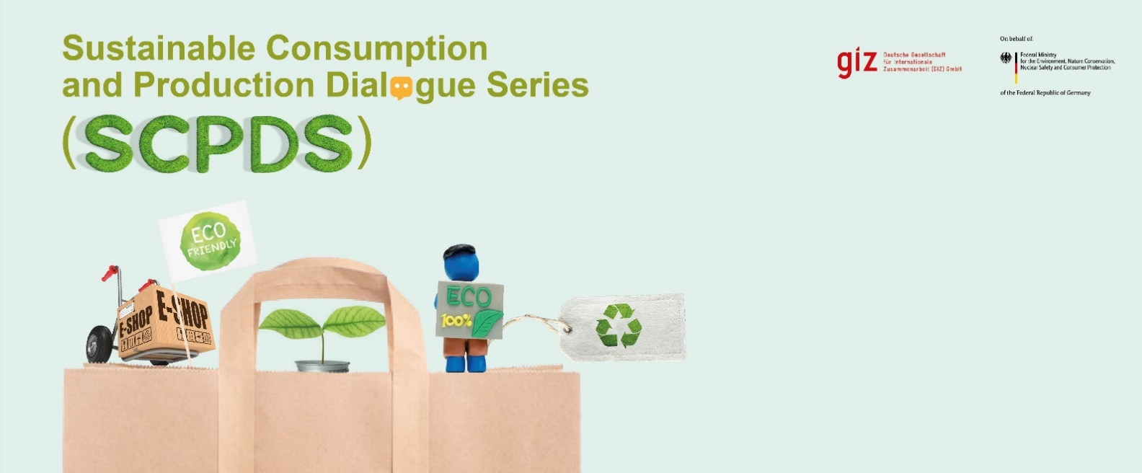
The SCP Dialogue Series opens new chapters in South-East Asia (SEA) Sustainable Consumption and Production (SCP) debate. Responding to the accelerating environmental crisis and the economic melt-down of the pandemic some countries have designed ambitious circular economic development strategies. One example is Thailand that has developed the Bio-Circular and Green Economy Strategy (BCG Strategy), which aims to develop economic growth, reduced inequality, sustainable nature and environment and foster self-resilience. Also, SEA countries have drastically increased their climate-change mitigation pledges during the COP 26: Thailand’s, Malaysia’s and Vietnam’s leaders have committed to carbon neutrality by 2050. While moving to renewables can address 55% of global GHG emissions, to achieve UN climate goals it is imperative to tackle the remaining 45% through designing out waste and keeping materials in use.

To implement the circular economy on a large scale with a wide reach, and to meet ambitious GHG reduction targets, countries need robust, transformative and impactful instruments. Sustainable public procurement (SPP) and Ecolabels have gained significant importance in the past years to pull markets towards more sustainable products and services. While the parallel Barrier Analysis Dialogue Series sheds a light on the challenges to implement these tools, this SCP Dialogue Series addresses the next concrete development steps to make these tools more impactful, focused and measurable.
Get inspired by country cases (advanced and countries in development) and get insights in policies how governments can fundamentally change the way goods and services are produced. We will provide you insights in SPP monitoring systems to measure GHG mitigation and cost-savings. We will introduce you to connecting digital green product lists to e-procurement and e-catalogues. We will introduce you to material efficiency for product life-time extension and CE product/service criteria, as well as circular procurement. We will explore the massive potential of SPP in the public works, the ICT and the cooling sector. Finally, we will take an outlook on inter-ministerial coordination and moving to mandatory product standards.
For each of these topics we will provide you with an easy-to-read pre-study and link key-documents, and in our partner countries, we will follow-up with workshops to develop tangible policy documents.

Objectives
- To bring together policymakers, experts, businesses and practitioners with a passion for SPP and EL as a means to influence consumption patterns to minimize the environmental damage caused by goods and services.
- To be inspired by country cases on policies, regulations, best practices, and business models that foster the implementation of EL and SPP.
- To gain knowledge on key-features for an impactful SPP and EL implementation.

Language
- The event main language will be English with Thai and Bahasa simultaneous translation provided.

Target Groups
- Policy- and decision makers, civil servants and practitioners from the ASEAN region, but also across the world, developing SPP and EL systems.
- Business associations, companies, organisations and individuals who are passionate about the topic of EL and SPP.

Format
Each dialogue series is two-hour long and takes place via Kudo. Prior to the event, it is recommended to read the specific publication.
Event Titles | Dates | Link to Recording
Ecolabels & Sustainable Public Procurement (SPP) Monitoring Systems, including SPP Index | 26 April 2022 | https://www.youtube.com/watch?v=zmhWo4SW8RQ
Boosting sustainable public procurement (SPP) through enhanced market information: E-catalogues and E-marketplaces | 21 June 2022 | TBC
Circular Economy (CE) product/service criteria and circular procurement, including Product Services System | 26 October 2022 | TBC
Green Public Procurement in the public works sector: material, components and services | December 2022 | TBC
Product-policies for digitisation & Information Communication Technology (ICT), focus on data-centre/ software | February 2023 | TBC
Inter-ministerial coordination for CE policies, moving to mandatory? | April 2023 | TBC
The session starts with a short summary and presentation of key message from the authors of the publication from the Öko-Institut, a leading environmental research institute. Additionally, up to 3 policymakers, practitioners, organisations and individuals from around the world will be invited to share and reflect on their experiences.

About Scaling SCP
This activity is organised as part of the project “Scaling Sustainable Consumption and Production (Scaling SCP): Ecolabelling and Sustainable Public Procurement for a Low-Carbon Pathway in South-East Asia”, which is commissioned by the German Federal Ministry for the Environment, Nature Safety and Consumer Protection (BMUV). The aim is to develop and establish policy instruments and policy frameworks in the area of SCP to promote a low carbon economy and contribute to national GHG emission reduction. To support this transition, the project has partnered with the governments of Thailand, Malaysia, Indonesia, and the Philippines with activities running from 01/2022 – 12/2024.
For upcoming events, visit: www. greentechknowledgehub.de/partner-events
For any queries about the
Dialogue series, write to:
Anusara Tanpitak,
PR and KM Coordinator,
SCP Hub, GIZ
anusara.tanpitak@giz.de

Ellen MacArthur Foundation: Completing the Picture, 2019: link

