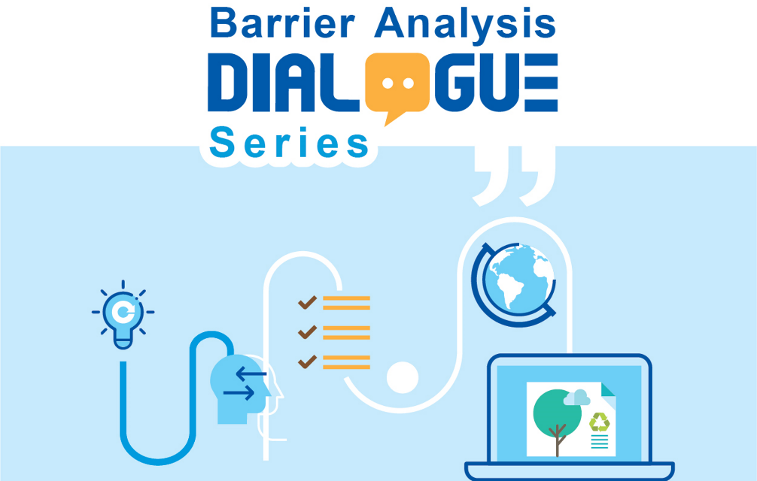
The Barrier Analysis Dialogue Series (BADS) is a bi-monthly discussion and debate around how the concept of green or sustainable public procurement (SPP) and ecolabels (EL) can be applied to steer towards a greener and circular economy (CE). Get inspired by country cases (advanced and countries in development) and get insights in policies and strategies that demonstrate how governments can fundamentally change the way goods and services are procured. See the full publication here.

First, we will introduce the underlaying barriers to a green and circular economy, such as externalized costs and the split incentive dilemma. This will help us to understand how to design product policies to make circular economy work. Next, we will inspire you how governments can lead the transformation by making SPP work, or simply put to “Walk the Talk”. Then, we introduce tools on how to build trust in the market through EL and other green claims, as well as green product catalogues, an important tool to boost SPP.
However, we do not want to hold back on the limits of EL and SPP. There are barriers on the private sector and the government side which needs to be addressed. In economies with insufficient domestic manufacturing sector the EL tool needs special attention, while the mismatch with supplier branding strategy and fast innovation cycles of products might additionally hinder an effective implementation of EL. Also, the critical support of the government to strengthen EL through SPP might be hindered, if EL are private or civil-society run. For SPP in return political support, a robust institutionalization and clear mandates are pivotal. We will guide you on how to get started and how to succeed with EL and SPP.

Objectives
- To accrue policymakers, experts, businesses and practitioners passionate about SPP and EL to influence consumption patterns to minimize the environmental damage caused by goods and services
- To be inspired by country cases on policies, regulations, best practices, and business models that foster the implementation of EL and SPP
- To expand understanding and learn about common barriers in their implementation and possible strategies for successfully overcoming these barriers

Language
- The event main language will be English with Thai, Khmer, Laos, Vietnamese and Bahasa simultaneous translation provided.

Target Groups
- Policy- and decision makers, civil servants and practitioners from the ASEAN region, but also across the world, developing SPP and EL systems.
- Business associations, companies, organisations and individuals who are passionate about the topic of EL and SPP.

Format
Each dialogue series is two-hour long and takes place via Kudo. Prior to the event, it is recommended to read the specific chapter of the Barrier Analysis publication.
Event Titles | Dates | Link to Recording
Making Circular Economy work in the product policy: Overcoming the barriers in Sustainable Public Procurement and Ecolabels | 22 March 2022 | TBC
Walk the Talk I: Governments lead the transformation | 24 May 2022 | TBC
Walk the Talk II: Making Sustainable Public Procurement work | 20 September 2022 | TBC
Insufficient domestic manufacturing sector | 29 November 2022 | TBC
Mismatch with supplier branding strategy, fast innovation cycles and non-state ecolabels | January 2023 | TBC
Unclear mandate for SPP and ecolabel establishment | March 2023 | TBC
Getting started with Ecolabels and SPP | May 2023 | TBC
The session starts with a short summary and presentation of key message from the authors of the publication from the Öko-Institut, a leading environmental research institute. Additionally, up to 3 policymakers, practitioners, organisations and individuals from around the world will be invited to share and reflect on their experiences.

About SCP Outreach
This activity is organised as part of the project “Proliferation of Sustainable Consumption and Production (SCP) in Asia – the Next 5 Countries (SCP Outreach)”, which is commissioned by the German Federal Ministry for the Environment, Nature Safety and Consumer Protection (BMUV). The aim is to develop and establish policy instruments and policy frameworks in the area of SCP to promote a low carbon economy and contribute to national GHG emission reduction. To support this transition, the project has partnered with the governments of Thailand, Vietnam, Cambodia, Lao PDR and Bhutan with activities running from March 2020 – February 2024.
For upcoming events, visit: www. greentechknowledgehub.de/partner-events
For any queries about
the Dialogue series,
write to:
Anusara Tanpitak,
PR and KM Coordinator, SCP Hub, GIZ
anusara.tanpitak@giz.de

